LAB 3 :

1. Write the statement to add your phone number into the given phonebook data structure and specify the name of the data structure used.



2.

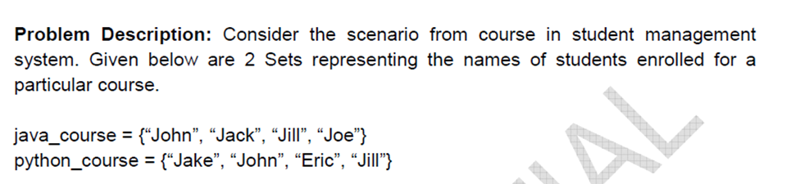







3. 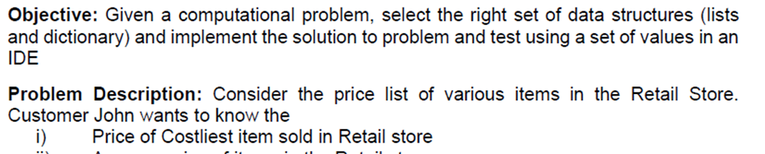

Use functions to find the same.

4.Given the details of three users of an online movies database, implement the below mentioned scenarios

A = { SW, HP, TW, MIB, MP}

B ={ HP, IP, TW, RR, KL, HJ}

C = { MP, TW, CJ, TT, QW}

(a) Display the movie/movies watched by all the three users

(b) Display the movies commonly watched by users A and B

(c) Display the most frequently watched movie.

5. 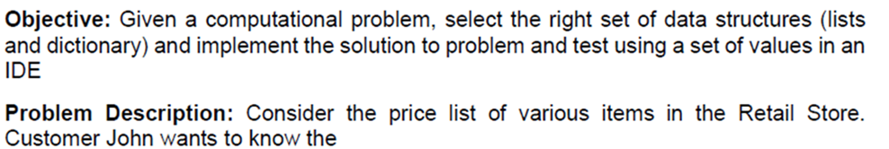



Use functions to find the same

6. Write a program for the below: